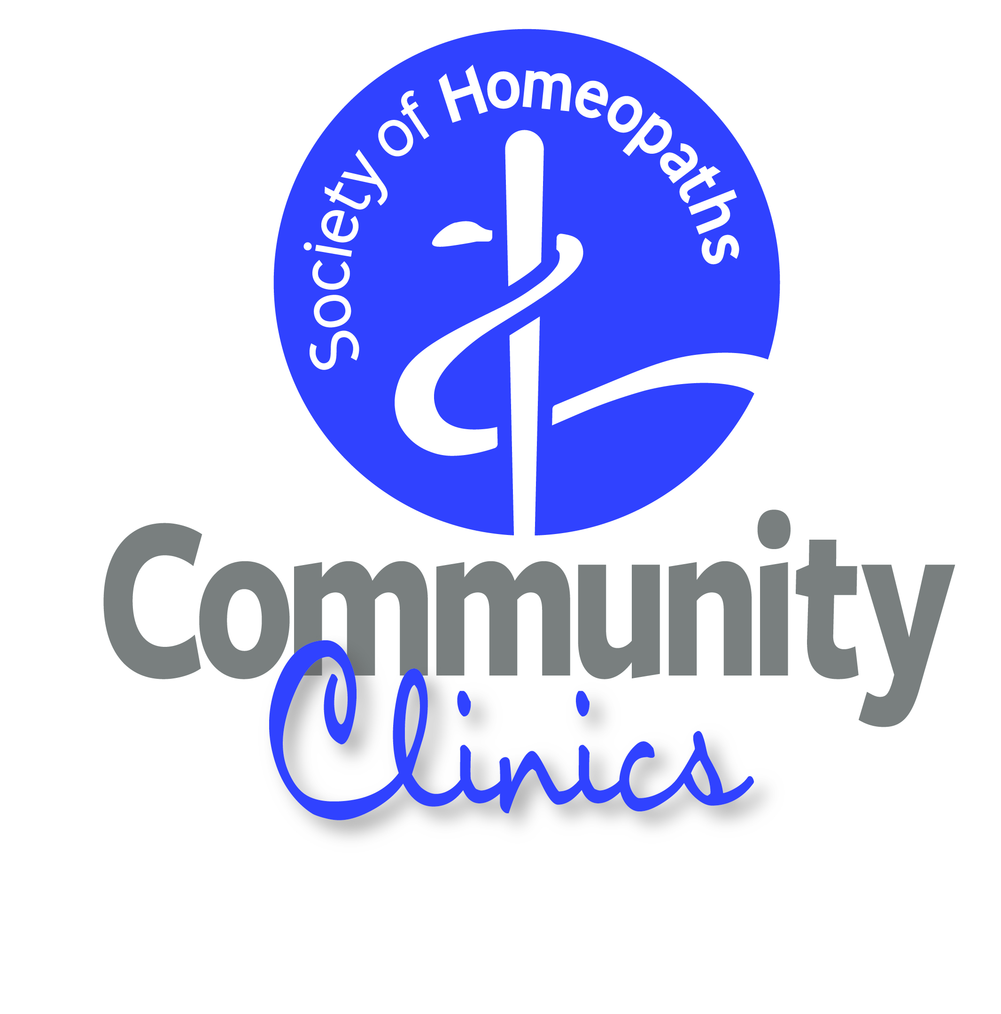
The Society Homoeopaths
Supported

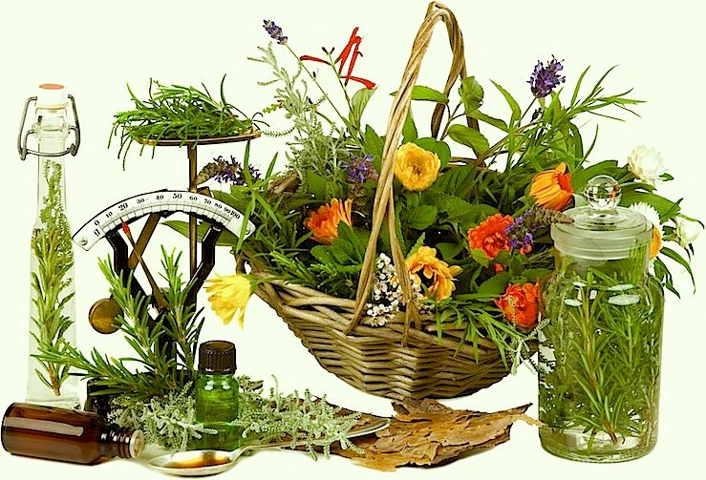
LOW COST CLINIC
This Photo by Unknown Author is licensed under CC BY-NC
HOMEOPATHY
Axminster Health and Well-Being
Clinic
Chard Road Axminster.
Starting in September

early registration of interest essential
Patricia Moroney RSHom
Jacqui Haylett RSHom
For information
Email: info@simplybetterhealth.co.uk

